Using the Network to Control the Kinetis KL05

**March 1, 2016**

**Team Members:**

Brendan Barry

Tatiana Ensslin

Table of Contents

Introduction 3

Methods 3

Wifi Communication- Using the ESP01 Wifi Bridge 3

Wifi Communication- Opening A TCP Socket with PuTTY and Connecting Wirelessly to ESP01 3

PWM-Using Pulse Width Modulation (PWM) on the Kinetis KL05 4

PWM-Vary the Duty Cycle 4

PWM-Connecting to an LED 4

PWM-Create Multiple PWM Signals 4

Wireless Control-Receiving commands from PuTTY on the KL05 5

Results 5

WiFi Communication- Using the ESP01 WiFi Bridge 5

WiFi Communication- Opening a TCP Socket with PuTTY and Connecting wirelessly to ESP01 7

PWM-Using Pulse Width Modulation (PWM) on the Kinetis KL05 8

PWM-Very the Duty Cycle 9

PWM-Connecting an LED 10

PWM-Create Multiple PWM Signals 10

Wireless Control-Receiving commands from PuTTY on the KL05 10

Discussion 10

Appendix A – Microcontroller Timers in Output Compare Mode 11

Appendix B – Hello World on the LCD 13

Appendix C – Interfacing a Keypad 17

Appendix D – Reaction Game 21

# Introduction

This lab report presents an application of the Freescale-NXP Kinetis KL05 ARM Cortex M0+ microcontroller along with a USBDM SWD programmer/debugger, a ESP01 with a WiFi Bridge, Pulse Width Modulation (PWM) and communication via WiFi using the PuTTY application, RealTerm with AT Commands, and the KLO5, as well as how to interface the microcontroller to change the colors of an LED through an algorithm using the PC.This application begins using the ESP01 Wifi bridge, opening a TCP socket with PuTTY and connecting wirelessly to the ASP01, using PWM to create components and vary the duty cycle and connect one PWM to each R,G,B on the LED, and finally combining it all together to receive commands from PuTTY on the KL05 through the help of UART. By the end of the experiment, one will be able to understand communication between the KL05 and the ESP01 WiFi Bridge, as well as TCP socket communication, PWM on the KL05 and commands using RealTerm and PuTTY. One will also become familiar with Kinetis Laboratory and its workspace. All code can be seen in the Appendix.

# Methods

## Wifi Communication- Using the ESP01 Wifi Bridge

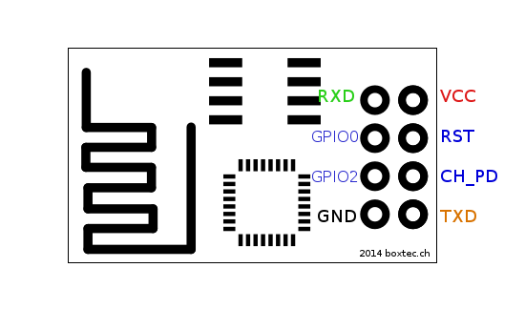For this section, the first step is to establish a UART link between the desktop PC and the ESP01 WiFi module using RealTerm. To do this, we will send AT Commands over the UART communication protocols. We will use the AT commands to retrieve the WiFi module connected and the assigned IP address. We will connect to the network as a client, not host. The ESP module connects in Station Mode, Access Point Mode, or both. Do not connect as both, which creates two IP addresses. The name of the wireless network used in our experiment was “iot_lab” with the password “44FEC4DDB9.” The pin-out for the ESP01 is below:

The baud rate for the ESP01 is 115200. All AT instructions end with “\r\n.” This is option that can be toggled on RealTerm by selecting +CR +LF. To test the commands, try AT+RST\r\n and receive a response back. In order to obtain the IP and connect to the network, enter the following commands:

AT+CWMODE=1 //Selects station mode

AT+CWJAP=”iot_lab”, “44FEC4DDB9” //connects to network

AT+CIPSTA? //gets IP address

## Wifi Communication- Opening A TCP Socket with PuTTY and Connecting Wirelessly to ESP01

Next, we begin this section by creating wireless communication by creating a server. To start a server use AT Commands in RealTerm to control the KL05. Enter the following two commands:

AT+CIPMUX=1

AT+CIPSERVER = 1,798 //pick a port over 1024

After sending these commands and receiving OK, open PuTTY to create a connection from the PC over WiFi to the KL05. Configure the IP, Port, and connection type to raw and save the configuraton. After you have successfully connected, send “Hello” on PuTTY using on RealTerm the commands:

AT+CIPSEND=0,5 // 5 for 5 characters

HELLO

This should cause “Hello” to appear on the PuTTY GUI. To send from the PC to the KL05, type “Hello World” on PuTTY and note its appearance on RealTerm.

## PWM-Using Pulse Width Modulation (PWM) on the Kinetis KL05

For this section, create a project using KDS for the KL05 and add a PWM component. Choose an arbitrary period for the unit and use the SetRatio16 method to assign an arbitrary duty cycle. Run the code via the debugger and observe the PWM output on WaveForms. Verify the signal matches the settings you created by using the cursors on the WaveForms program. For out component, we selected a PWM_LDD with a period of 100ms and a starting pulse width of 6.24ms. We connected to Waveforms with pinPTB11.

## PWM-Vary the Duty Cycle

In this part of the experiment, you will write code that will set the duty cycle, delay, change the duty cycle, delay, etc. Be sure to make the delay last for one second and have the duty cycle change to five different values between 0 and 0xFFFF. Choose very small, small, medium large, and large duty cycles. Have the code continuously loop through the changing PWM signals. Observe the signal on WaverForms. For our settings we chose: 1311,19660,32768,49151,65535.

## PWM-Connecting to an LED

LEDs are constant voltage devices. Infrared and red ones require about 1.5V, orange and yellow about 2V, and green, blue, and white about 3V. This means that they should not be connected without a resistor, or else is possible that they can break. Connect an LED to the PWM pin on the KL05 with a suitable resistor. Larger resistors means dinner LEDS, therefore start with a 1K-Ohm. When connected to the LED through the resistors, notice the LED dimming to 5 different brightness levels. If the LED is blinking, ensure the period is below 16ms, or ensure that all the proper channels are set. If the LED is too bright or too dim, then the resistors will need to be changed.

## PWM-Create Multiple PWM Signals

For this section, modify or create a new Kinetis project to contain 3 PWM components. Make all three have the same period appropriate for dimming an LED. Ensure that they are on separate duty devices beginning with TPMO_ and all have their own proper pin. Next, connect an RGB LED to the PWM pins: one PWM for red, one for green, and one for blue. Write code that controls the brightness of the LEDs in a nested fashion (three nested for loops). The code should dim each LED completely off (0), half brightness (.5), and fully on (1). This will create a display that will show all 27 different colors, including all LEDs off (black) and all on (white). Be able to demonstrate the colorful display.

## Wireless Control-Receiving commands from PuTTY on the KL05

Begin by using the KL05 and modifying our circuit to have the PC connect to the WiFi network, as well as use the USB Cable to connect the programmer to the KL05 to the LED to the UART. This means we will have wireless control of the LED and wont use RealTerm except to initialize PuTTY. All communication with the ESP01 module will be done using the KL05. We will preform as much setup as possible using RealTerm and then move the wires over to the KL05. The only visible indication that the KL05 is running is observing changes in the LEDs, the end goal. The final part of this experiment is to create your own custom protocol on the application layer which will include HTTP, FTP, and SSH. Previous, an open socket was created using PuTTY with “raw” protocol/no protocol. This created protocol will control the color of the LED by typing commands into PuTTY and receiving and interpreting them through the KL05. The KL05 will then allow the protocol to assign the colors red, green, blue, orange, yellow, purple, white, and black, as well as a custom color. After redesigning your circuit, create a new serial component with a baud rate of 115200. Create your protocols by studying what is sent from PuTTY to RealTerm and parsing what is received by the KL05.To parse commands for each color, we chose to use IF statements which checked a character array which ran till “/r” or the received data. When parsing custom numbers, we did the same thing, as well as a math conversion, which also uses the strltol function, casting, and the floor function. It also is helpful to set the server timeout to the max setting 7,200 seconds using RealTerm and the AT+CIPSTO = command. After, display that you can change the color of the LED wirelessly from the PC to the KL05.

# Results

## WiFi Communication- Using the ESP01 WiFi Bridge

This section will focus on Output Compare Mode—also know as wasting an exact amount of time. This may be used to connect the Timer Unit Hardware directly to an I/O pin. On the HCS12, the I/O Port T can control the timer. The timer can also be implemented apart from I/O. There are two registers in the Timer Hardware Unit. They are the timer counter resiter (TCNT) and the output compare registers (TCx). There are 8 output compare registers (TC0-TC7), meaning 8 timers can be implemented at a time. When TCNT equals TCx, a flag is set. The steps we used in implementing the timer is as follows:

* Set up the timer by writing to the timer control registers at the beginning of the program.
* Read the 16-bit timer counter register TCNT and add a delay.
* Place the result into the output compare register TCx.
* As an example: TC2 = TCNT + 0x3A58, which configured a delay of 14,936 timer counts on timer 2.
* Wait for the flag to be set. While(!TFLG1_C2F).
* Take note that when creating a repeating delay, the delay should be added to the output compare register. TC2=TC2+ 0x3A58. This will eliminate any timing errors that will be associated with overhead due to software delays.

We configured the timer to create a square wave in 26Hz. First, we set the I/O pin to enable the data direction and then we configured the timer to automatically flip the I/O pin using the toggle option. The frequency will be verified via the oscilliscope. To find the delay in time for the 26Hz:

6x106 / 128 = 46875Hz 46875Hz/26Hz = 1802.9 1802.9/2 = 0x386 (note: 128 is prescale: 111)

SPEEDUP-Note that because its software, when the program is halted, the square wave should stop entirely. In comparison to hardware, where the wave will continue slowed down.

To speed up to 100kHz:

6x106 / 100kHz = 60 60/2=30 with no prescale. This correlates to about 9.96 micro seconds.

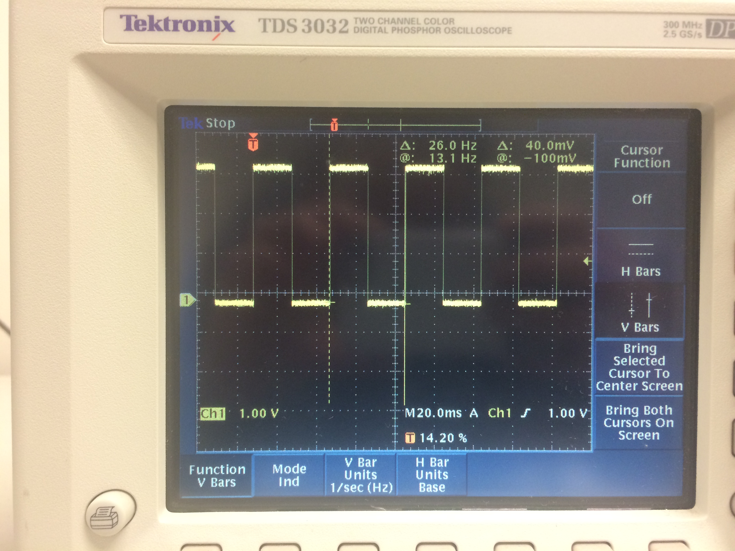

To the left is the software created square wave going at 26Hz.

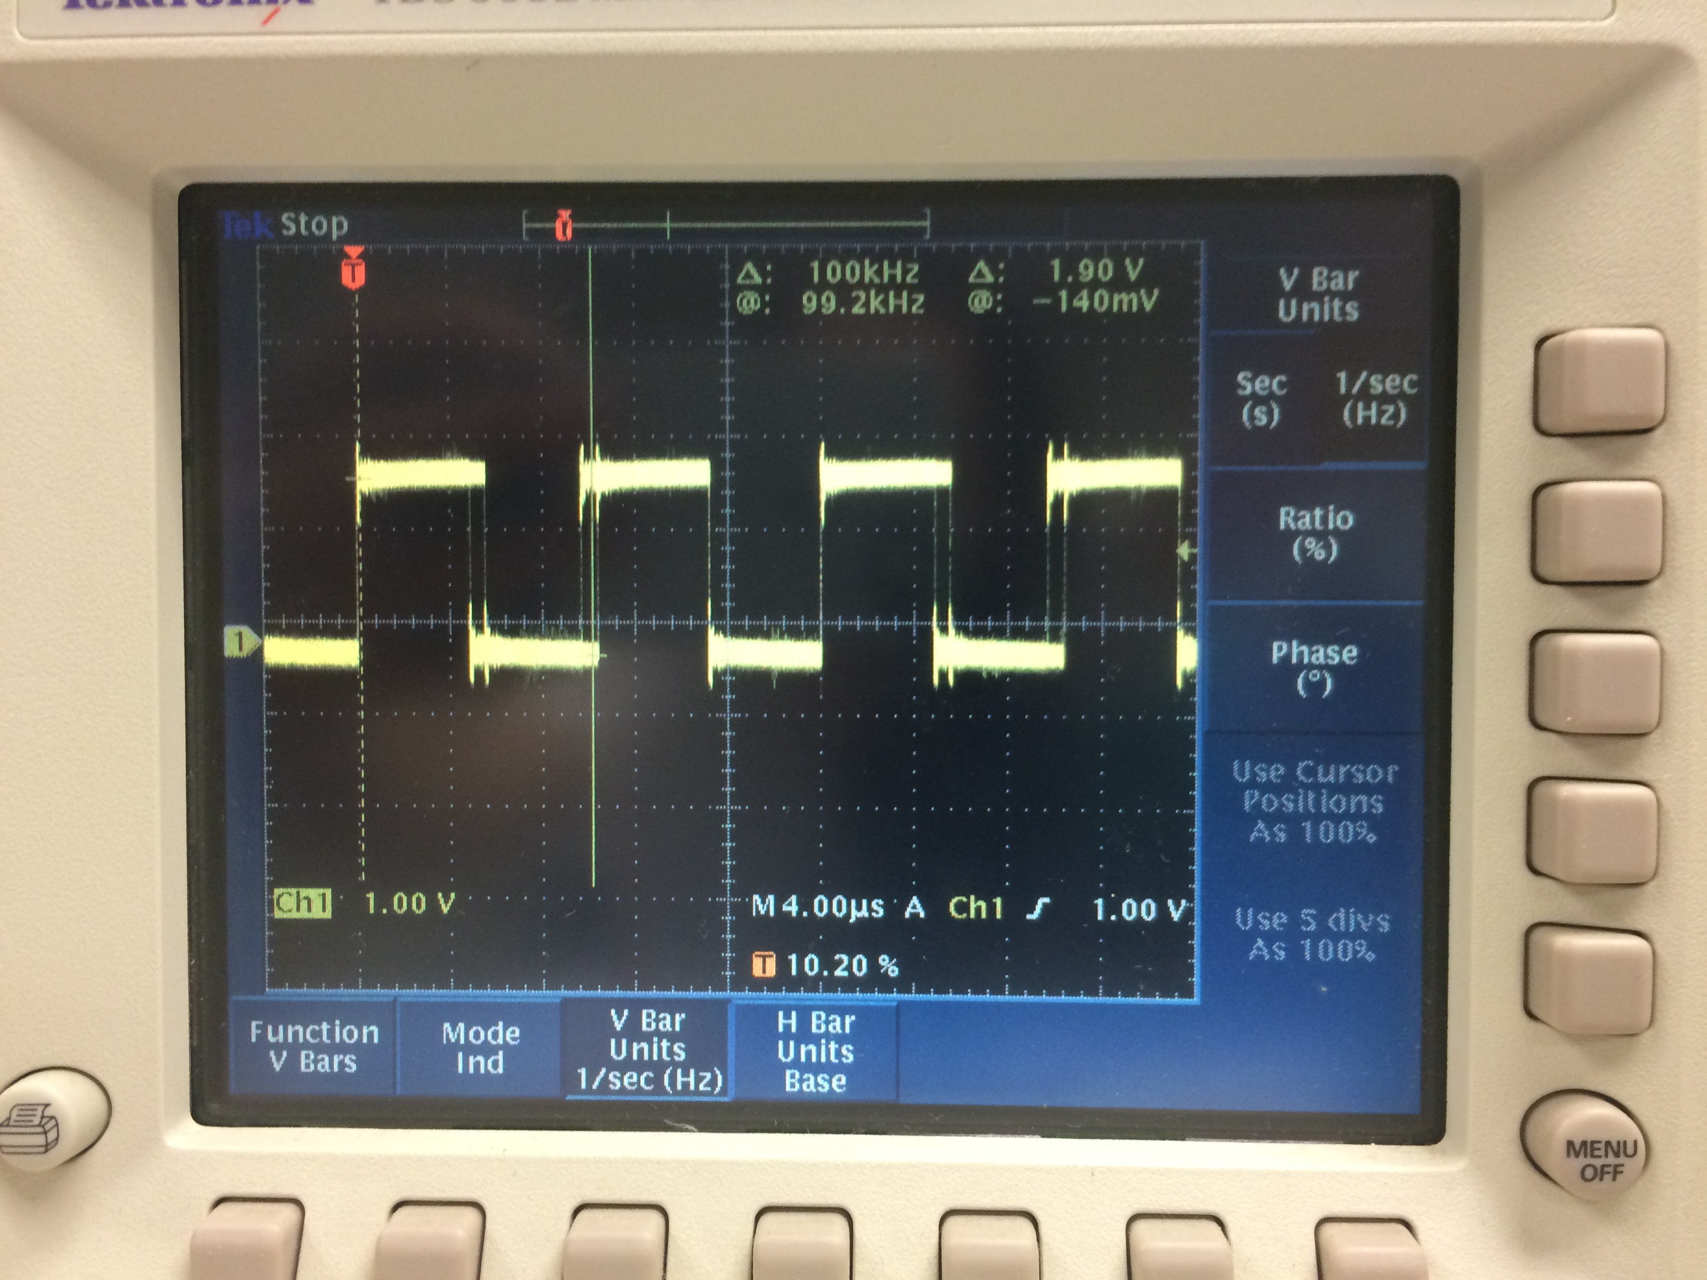

To the right is the software created square wave going at a speed of 100kHz. Note the jitter on the wave.

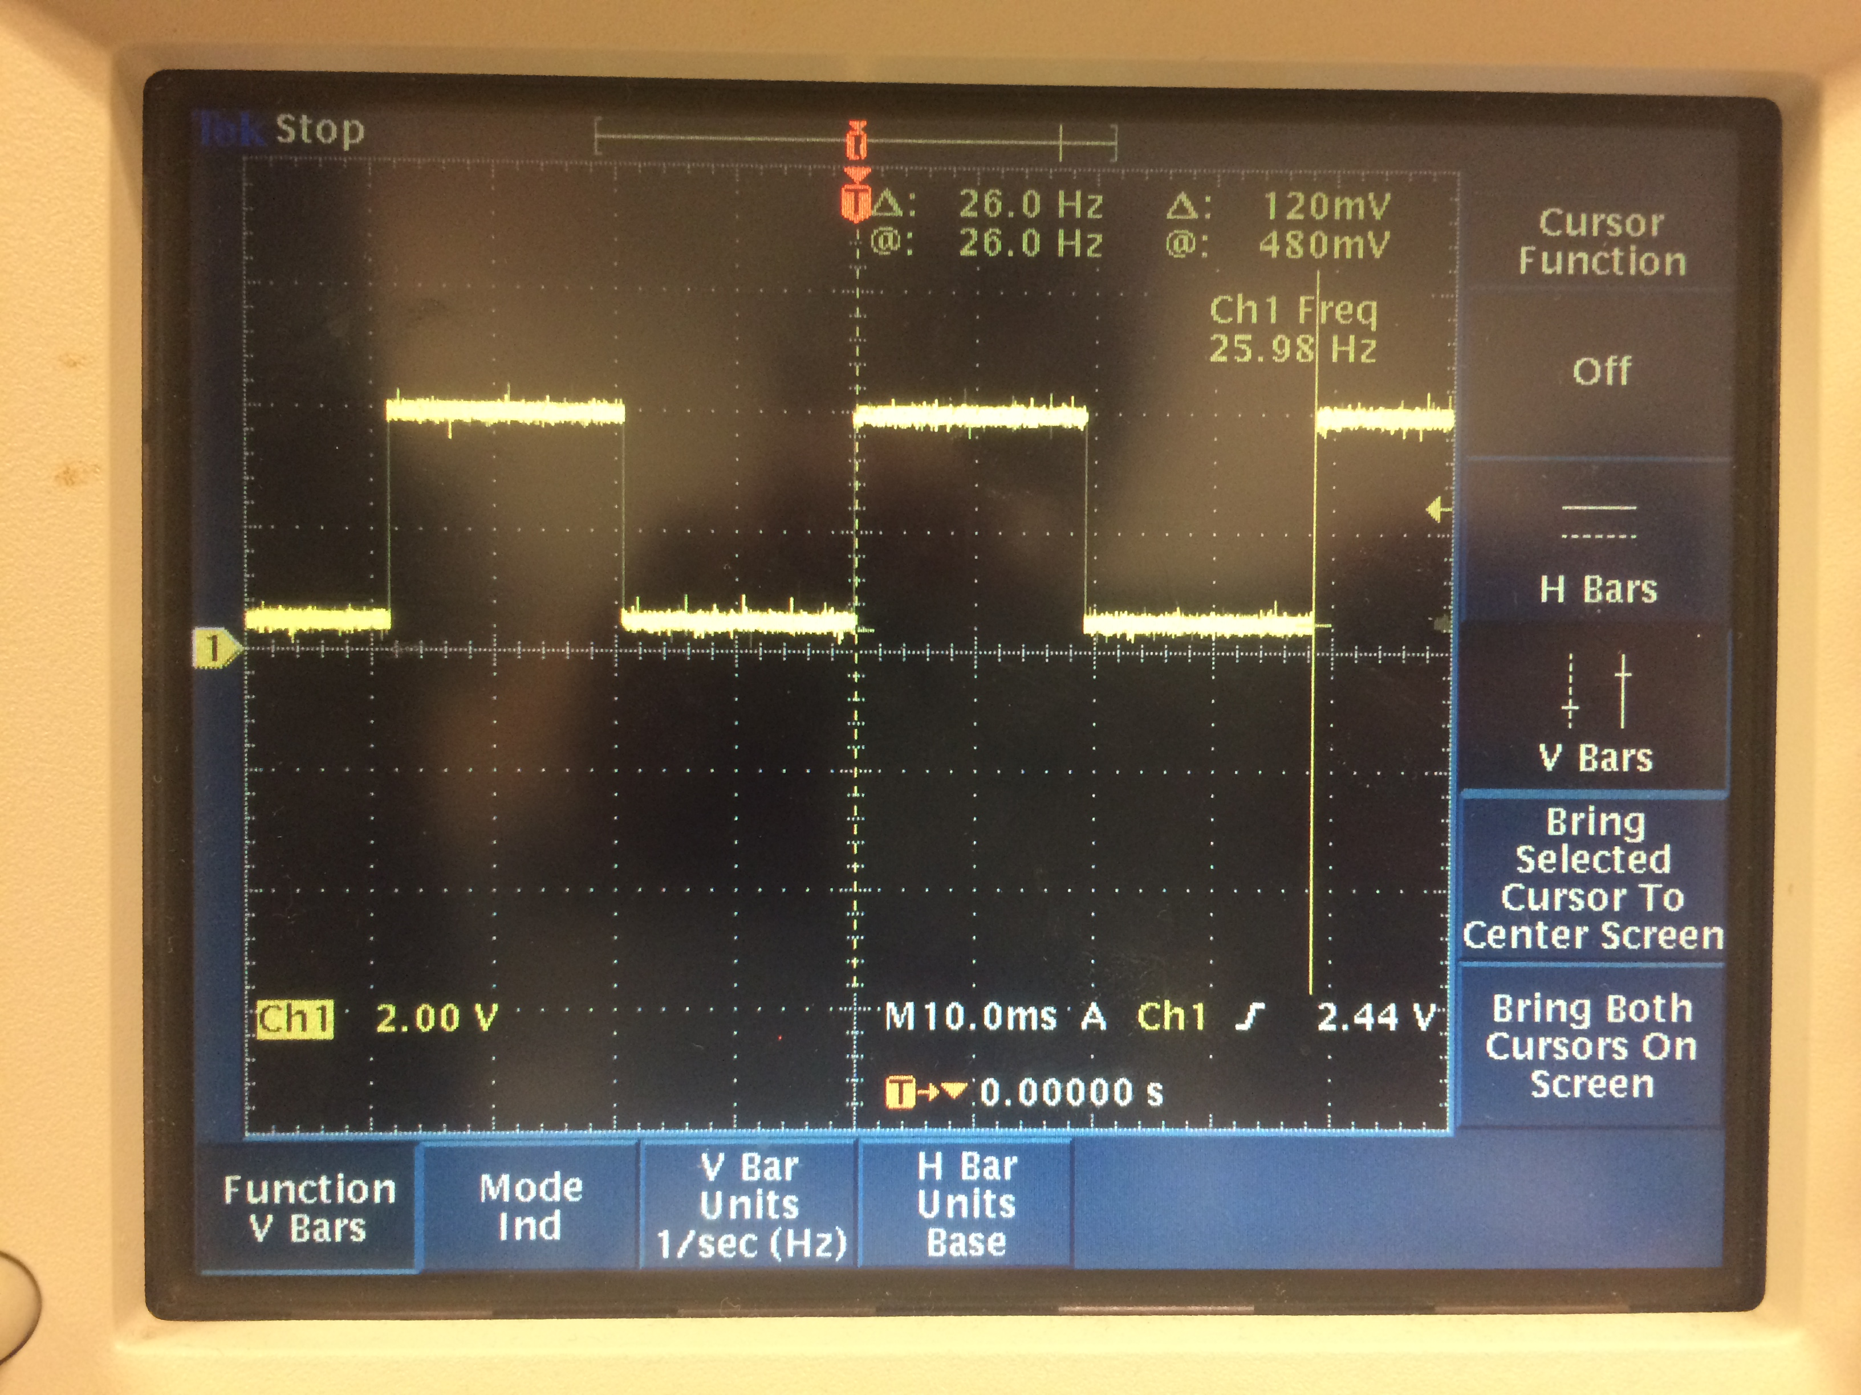

To the left is the 26Hz square wave created through the hardware

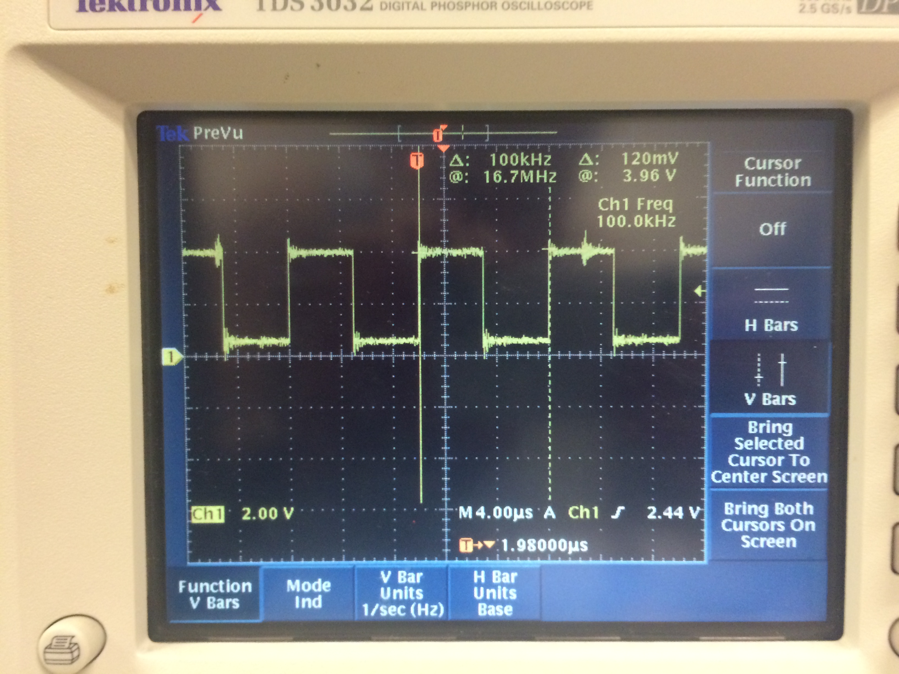To the rigth is the 100kHz square wave created by the hardware. Note the jitter on the wave.

Note the jitter which can be seen on the faster 100kHz square waves. Also, it is important to mention that we had to set the prescaler to divide by 128 for our delay time to accurately slow down the frequency on the 26Hz . The prescaler was removed for the 100kHz frequency. The code for this section can be found in the appendix.

## WiFi Communication- Opening a TCP Socket with PuTTY and Connecting wirelessly to ESP01

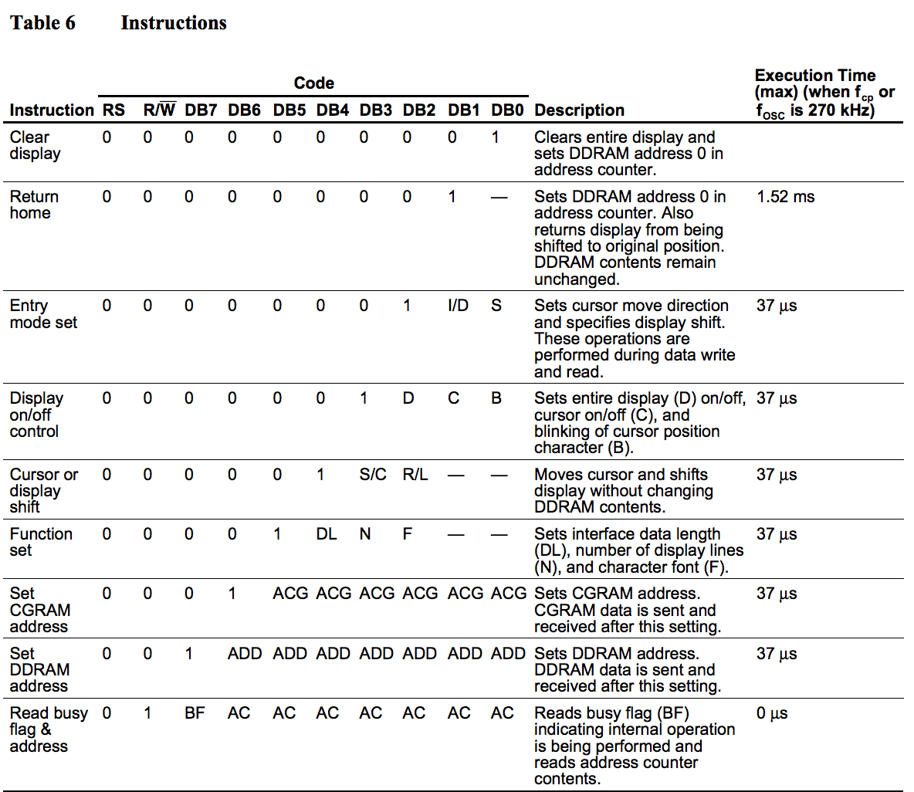 The LCD is located on the Altera DE2 board. We will create a small VHDL circuit that simple connects the LCD pins to the 40-pin header. This will allow us to control the LCD using the HCS12 microcontroller. Using interfacing information about the LCD, we will write a small piece of software that will display “Hello World” on the LCD. In order to make sure we can format the LCD screen, we will display Hello World left justified, along with showing Tatiana and GX centered on the second line. We set two P Ports and 8 AD ports for this section. We will use the timer and set it to 90 for a 49 microsecond delay, and 300 for a 1.65ms delay. This means we need to keep the prescale set to all 0’s. There are two outputs we will be coding on the Altera in VHDL, the LCD_ON and LCD_RW. Table 6 (seen right) on the LCD microcontroller’s data sheet contains the list of signals that can be used to send instructions to the LCD. We will use its 8-bit mode. The process of sending our data to the LCD is as follows: Connect power. Set function set (tells what bits to set). Display on control (set to enable). Set entry mode to 8-bits. Write data in ASCII. Set DDR address (this shifts the cursor to the second line at address 0x064 (if set to that address)). We use VHDL code with 11 inputs and 11 outputs. This will allow us to connect the 40-pin header to our LCD display. To center the 40-Pin header to out LCD display we sent the function set, display control, entry mode set, writing “Hello World”, then setting the DDR address instruction. We used 0xC4 to center our names (position) them on the second line. Our finished result can be viewed below. The code for this section can be found in the appendix.

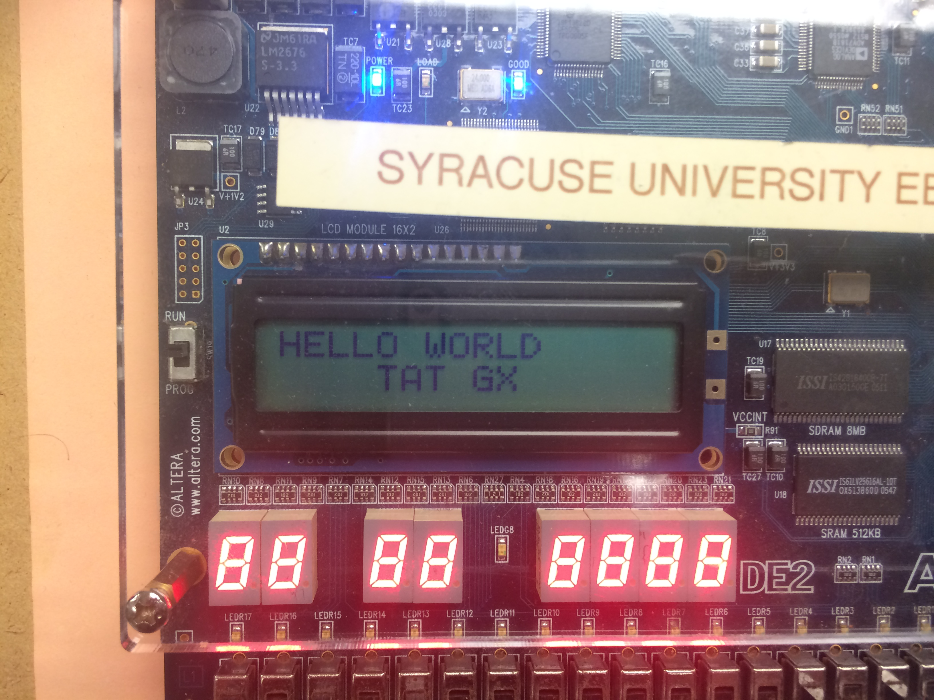

## PWM-Using Pulse Width Modulation (PWM) on the Kinetis KL05

We were given a 4x4 keypad, which is simply 16 switches connected by 8 wires. We will create an algorithm that will implement knowing the pressed button and display it to the LCD. The back of the keypad looks like:

We will have four inputs and four outputs. We will also set a pull enable and polarity register on our ports in order for all the ports to be initialized to ‘0’. Our algorithm will register a ‘1==1,’ which will then print that selected character. We will use an 8-pin header to connect the keypad to our controller. To do this, we set OCPD (enable T ports for non-timer use) to 0xFF and use the T ports to connect the keypad. We will set our rows as out and our columns as in. T0-T3

1 2 3 A

4 5 6 B

7 8 9 C

* 0 # D

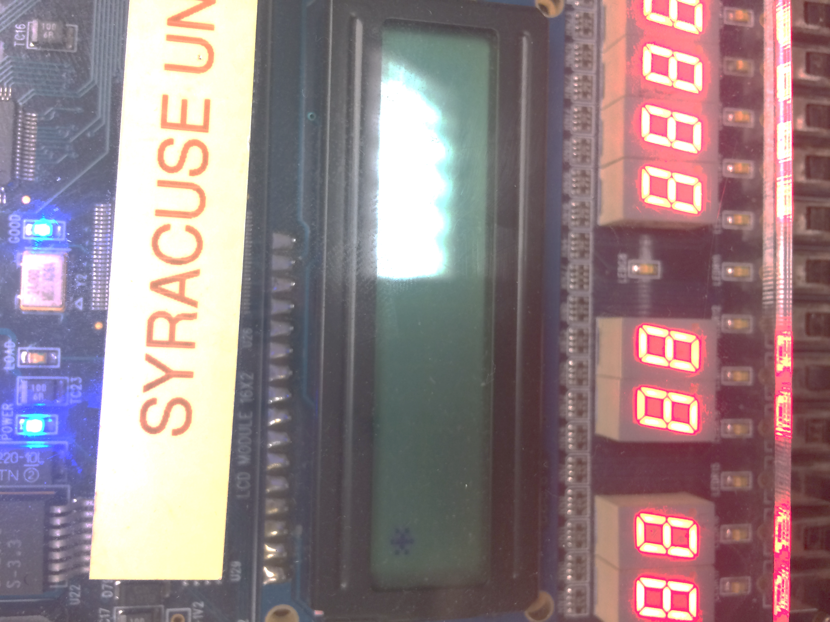are outputs and T4-T7 are our inputs. We now enable the pull registers, which will set all the T ports to ‘0.’ We also created multiple functions to clean and ease the code, such as an enable function which sets the enable bit to ‘1’ then ‘0,’ a cleardisplay function, as well as a writedata function which intakes a character to be printed out. These functions and others include a special delay calculated for the keypad between buttons. Our VHDL code remained the same from the last part. Note that in our code, we clear the LCD screen before changing to the next character. When using the keypad, the wires can have bounce, which is due to the 8 wires crossing unintentionally when a button is pressed. This can be resolved through a small delay, which allows for the full ‘1’ of the button press to be registered. The code for this section can be found in the appendix.

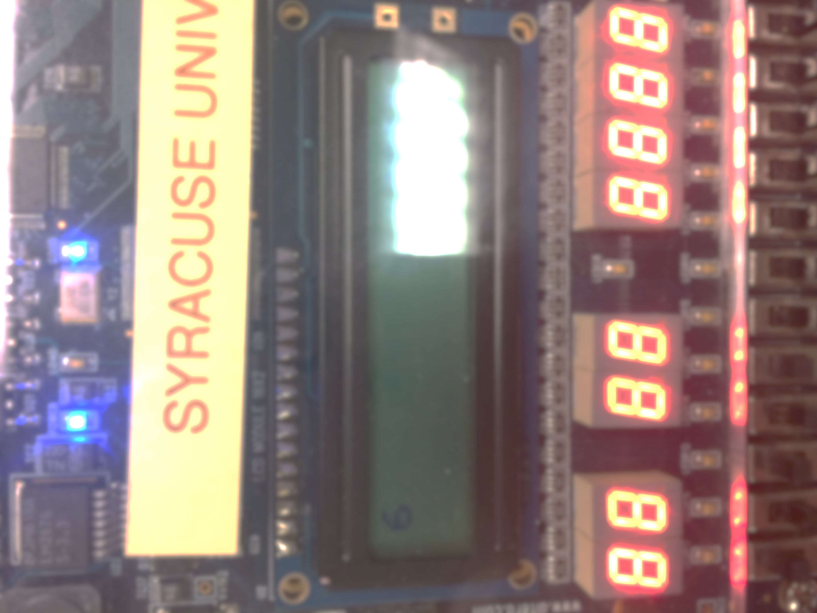

To the left are screenshots of two of the characters being displayed properly on the LCD display after being pressed on the keypad.

## PWM-Very the Duty Cycle

This game started by displaying “Press any key to begin.” When a key on the keypad is pressed the program should clear the screen and then display two of the 16-keypad characters randomly on the first line of the LCD. The user will then press the two characters. Upon correct input, the microcontroller will then capture the keys and display the time between the last character displayed on the LCD and the last character pressed on the keypad. The time will then display on the second line of the LCD to the nearest ms, saying “Reaction xxx ms.” The game should reset after a 5-10 second delay. For the counter, we set TCNT to a variable and when the two buttons are finished being properly inputted, saved TCNT to another variable. We then found the difference from those variables. After, we converted this difference to milliseconds and then to seconds (x1000), and the frequency to time/clock cycles. 1/6,000,000 is the time for 1 clock cycle. 216 (size of TCNT) –1/6,000,000. Therefore, with our timer prescaler, we divide the reaction time x1000 by 46875 to get out time to display in ms. After this, we get the time that we would like to display on the LCD, however, in order for it to be displayed, it needs to be modded by 10 in order to be split up by places to be printed because the number is longer than 1 character. Unfortunately, due to a byte compile error restriction, we were unable to debug past this stage in our code and completed the remainder of the section. We tried splitting the code into a .h and .c file, and creating a new project to load them in, however we encountered link errors when trying to do so. Although we were unable to finish, you can see out unfinished code in the appendix.

## PWM-Connecting an LED

For this section, use RealTerm to capture the data running from the Kinetis Laboratory code. Clear the screen and start capture mode on RealTerm. Begin running the code and allow for a few seconds of data to send to RealTerm. Cease code and capture mode and output save the file to the working directory in RealTerm. Go into the directory and change the extension to .csv for use on Microsoft Excel. Load the file into Excel and select a column (x, y, or z) coordinates and select for a chart to be created as a representation of each coordinate value. Plot these charts over time.

## PWM-Create Multiple PWM Signals

For this section, use RealTerm to capture the data running from the Kinetis Laboratory code. Clear the screen and start capture mode on RealTerm. Begin running the code and allow for a few seconds of data to send to RealTerm. Cease code and capture mode and output save the file to the working directory in RealTerm. Go into the directory and change the extension to .csv for use on Microsoft Excel. Load the file into Excel and select a column (x, y, or z) coordinates and select for a chart to be created as a representation of each coordinate value. Plot these charts over time.

## Wireless Control-Receiving commands from PuTTY on the KL05

For this section, use RealTerm to capture the data running from the Kinetis Laboratory code. Clear the screen and start capture mode on RealTerm. Begin running the code and allow for a few seconds of data to send to RealTerm. Cease code and capture mode and output save the file to the working directory in RealTerm. Go into the directory and change the extension to .csv for use on Microsoft Excel. Load the file into Excel and select a column (x, y, or z) coordinates and select for a chart to be created as a representation of each coordinate value. Plot these charts over time.

# Discussion

This lab has provided us with a good understanding of what a microcontroller is capable of doing through its ports and with its timer hardware component. The timer Output Compare Mode, is extremely useful in being able to communicate with the LCD display, for it allows us to insert delays between instructions being sent to the LCD microcontroller. Once again, we learn that the microcontroller has multiple capabilities for communication protocols that can be useful when programming a complex device/project. The microcontroller itself contains several programmable registers, which allow the microcontroller to preform different actions on its ports. This principle is apparent in and throughout this lab. We used the Port T in the beginning as a I/O for the timer’s output compare, however, we broke it off of the hardware and used it in the third section to program the keypad in conjunction with the microcontroller and the LCD display. We used all 8 AD Ports in the second section to connect the LCD display to the microcontroller, as well as using two M Ports in order to control the instructions being sent over to the LCD display. The most difficult part of this experiment was being able to distinguish the prescaler’s size in order to accurately get the precise time needed for each function to allow it to implement to the best performance. Additionally, it was extremely frustrating to experience a delay that was too long on the keypad’s algorithm and see how it created a delay on the LCD display. Through trial and error, we were eventually able to figure out the cause of our errors in our timing by using the debugging tool to correctly identify the proper registers and logic to successfully complete the section. Lastly, although we were unable to finish the reaction game in the last section, we were able to complete most of it and realize that section truly tested our knowledge of being able to use the timer hardware, as well as properly implement the logic to create a working game. Unfortunately, because of the byte limit, our design was really pressured to take strange shapes, and then eventually unable to even be completed. Although we couldn’t finish, to see how to interface the keypad in terms with both the LCD’s microcontroller and the HCS12 microcontroller, this experiment was by far one of the best of the semester.

Although we did encounter a few challenges while working through this lab, such as selecting incorrect registers to program, or picking an un-programmable port (in our Hello World section, we used the T ports originally, which caused an interference with the timer, which was using the port T0), our initial approach to implementing the microcontroller’s hardware unit in terms with external hardware was primarily correct. Through use of the datasheet, header file in the CodeWarrior, and knowledge about the communication protocols for both microcontrollers, we found the use of the timer hardware component to be critical to being able to fully implement larger projects and experiments.

# Appendix A – Microcontroller Timers in Output Compare Mode

Software SLOW (26Hz):

#include <hidef.h> /* common defines and macros */

#include "derivative.h" /* derivative-specific definitions */

void main(void) {

TIOS_IOS0 = 1; //enable output compare for timer0

TSCR1_TEN = 1; //enable main counter/timer

TSCR1_TFFCA = 1; //enable flag to clear

TSCR2_PR0=1; // divide the prescaler 128

TSCR2_PR1=1;

TSCR2_PR2=1;

OCPD = 1;

TC0=TCNT + 0x386; //26Hz in clock cycles

DDRT_DDRT0 =1;

PTT_PTT0 =1;

while(1){

TC0=TC0 + 0x386;

while(!TFLG1_C0F){}

PTT_PTT0 =!PTT_PTT0;

}

}

Software FAST (100kHz):

#include <hidef.h> /* common defines and macros */

#include "derivative.h" /* derivative-specific definitions */

void main(void) {

TIOS_IOS0 = 1; //enable output compare for timer0

TSCR1_TEN = 1; //enable main counter/timer

TSCR1_TFFCA = 1; //enable flag to clear

TSCR2_PR0=0; // divide the prescaler 128

TSCR2_PR1=0;

TSCR2_PR2=0;

OCPD = 1;

TC0=TCNT + 30; //26Hz in clock cycles

DDRT_DDRT0 =1;

PTT_PTT0 =1;

while(1){

TC0=TC0 + 30;

while(!TFLG1_C0F){}

PTT_PTT0 =!PTT_PTT0;

}

}

Hardware SLOW (26Hz):

#include <hidef.h> /* common defines and macros */

#include "derivative.h" /* derivative-specific definitions */

void main(void) {

TIOS_IOS0 = 1; //enable output compare for timer0

TSCR1_TEN = 1; //enable main counter/timer

TSCR1_TFFCA = 1; //enable flag to clear

TTOV_TOV0 = 0x01;

TCTL1_OL4 = 1;

TCTL1_OL5 = 1;

TCTL1_OL6 = 1;

TCTL1_OL7 = 1;

TCTL2_OL0 = 1;

TCTL2_OL1 = 1;

TCTL2_OL2 = 1;

TCTL2_OL3 = 1;

TSCR2_PR0=1; // divide the prescaler 128

TSCR2_PR1=1;

TSCR2_PR2=1;

TC0=TCNT + 0x386; //26Hz in clock cycles

DDRT_DDRT0 =1;

PTT_PTT0 =1;

while(1){

TC0=TC0 + 0x386;

while(!TFLG1_C0F){}

}

}

Hardware FAST (100kHz):

#include <hidef.h> /* common defines and macros */

#include "derivative.h" /* derivative-specific definitions */

void main(void) {

TIOS_IOS0 = 1; //enable output compare for timer0

TSCR1_TEN = 1; //enable main counter/timer

TSCR1_TFFCA = 1; //enable flag to clear

TSCR2_PR0=0; // divide the prescaler 128

TSCR2_PR1=0;

TSCR2_PR2=0;

OCPD = 1;

TC0=TCNT + 30; //26Hz in clock cycles

DDRT_DDRT0 =1;

PTT_PTT0 =1;

while(1){

TC0=TC0 + 30;

while(!TFLG1_C0F){}

PTT_PTT0 =!PTT_PTT0;

}

}

# Appendix B – Hello World on the LCD

#include <hidef.h> /* common defines and macros */

#include "derivative.h" /* derivative-specific definitions */

void enable();

void main(void) {

DDR1AD0=0XFF;

DDRM_DDRM2=1;

DDRM_DDRM3=1;

//Timer Initializations

TIOS=0XFF;

TCTL2=0X10;

TSCR1_TEN=1;

TSCR1_TFFCA=1;

DDRT=0xFF;

TSCR2=0x03;

OCPD_OCPD2=1;

TC0=TCNT + 300; //49mic delay

while(!TFLG1_C0F){}

TC0=TCNT + 300; //49mic delay

while(!TFLG1_C0F){}

//clear screen

PT1AD0=0X01;//CLEAR DISPLAY

PTM_PTM3=0; // RS

PTM_PTM2=1; // SELECT DATA

PTM_PTM2=0;

TC0=TCNT + 300; //49mic delay

while(!TFLG1_C0F){}

TC0=TCNT + 300; //49mic delay

while(!TFLG1_C0F){}

TC0=TCNT + 300; //49microsecond delay

//functon set

PT1AD0 = 0x3F;

PTM_PTM3 = 0;

enable();

TC0=TCNT + 300; //49mic delay

while(!TFLG1_C0F){}

//display on

PT1AD0 = 0x0E;

PTM_PTM3 = 0;

enable();

TC0=TCNT + 300; //49mic delay

while(!TFLG1_C0F){}

//entry mode

PT1AD0 = 0x06;

PTM_PTM3 = 0;

enable();

TC0=TCNT + 300; //49mic delay

while(!TFLG1_C0F){}

TC0=TCNT + 300; //49mic delay

while(!TFLG1_C0F){}

//write data

PT1AD0 = 'H';

PTM_PTM3 = 1;

enable();

TC0=TCNT + 300; //49mic delay

while(!TFLG1_C0F){}

//write data

PTM_PTM3 = 1;

PT1AD0 = 'E';

enable();

TC0=TCNT + 300; //49mic delay

while(!TFLG1_C0F){}

//write data

PTM_PTM3 = 1;

PT1AD0 = 'L';

enable();

TC0=TCNT +300; //49mic delay

while(!TFLG1_C0F){}

//write data

PTM_PTM3 = 1;

PT1AD0 = 'L';

enable();

TC0=TCNT + 300; //49mic delay

while(!TFLG1_C0F){}

//write data

PTM_PTM3 = 1;

PT1AD0 = 'O';

enable();

TC0=TCNT + 300; //49mic delay

while(!TFLG1_C0F){}

//write data

PTM_PTM3 = 1;

PT1AD0 = ' ';

enable();

TC0=TCNT + 300; //49mic delay

while(!TFLG1_C0F){}

//write data

PTM_PTM3 = 1;

PT1AD0 = 'W';

enable();

TC0=TCNT + 300; //49mic delay

while(!TFLG1_C0F){}

//write data

PTM_PTM3 = 1;

PT1AD0 = 'O';

enable();

TC0=TCNT + 300; //49mic delay

while(!TFLG1_C0F){}

//write data

PTM_PTM3 = 1;

PT1AD0 = 'R';

enable();

TC0=TCNT + 300; //49mic delay

while(!TFLG1_C0F){}

//write data

PTM_PTM3 = 1;

PT1AD0 = 'L';

enable();

TC0=TCNT + 300; //49mic delay

while(!TFLG1_C0F){}

//write data

PTM_PTM3 = 1;

PT1AD0 = 'D';

enable();

TC0=TCNT + 300; //49mic delay

while(!TFLG1_C0F){}

TC0=TCNT + 300; //49mic delay

while(!TFLG1_C0F){}

//set DDRAM

PT1AD0 = 0xC4; //set to 1st line far left

PTM_PTM3 = 0;

enable();

TC0=TCNT + 300; //49mic delay

while(!TFLG1_C0F){}

//write data

PT1AD0 = 'T';

PTM_PTM3 = 1;

enable();

TC0=TCNT + 300; //49mic delay

while(!TFLG1_C0F){}

//write data

PTM_PTM3 = 1;

PT1AD0 = 'A';

enable();

TC0=TCNT + 300; //49mic delay

while(!TFLG1_C0F){}

//write data

PTM_PTM3 = 1;

PT1AD0 = 'T';

enable();

TC0=TCNT + 300; //49mic delay

while(!TFLG1_C0F){}

//write data

PTM_PTM3 = 1;

PT1AD0 = ' ';

enable();

TC0=TCNT + 300; //49mic delay

while(!TFLG1_C0F){}

//write data

PTM_PTM3 = 1;

PT1AD0 = 'G';

enable();

TC0=TCNT + 300; //49mic delay

while(!TFLG1_C0F){}

//write data

PTM_PTM3 = 1;

PT1AD0 = 'X';

enable();

TC0=TCNT + 300; //49mic delay

while(!TFLG1_C0F){}

while(1){

}

}

void enable(){

PTM_PTM2 = 1; //this is the enable for the LCD

PTM_PTM2 = 0; //this is the enable for the LCD

}

=============================================

library IEEE;

use IEEE.std_logic_1164.all;

use IEEE.std_logic_unsigned.all;

entity LCD is

port (

t0 : in std_logic;

t1 : in std_logic;

t2 : in std_logic;

t3 : in std_logic;

t4 : in std_logic;

t5 : in std_logic;

t6 : in std_logic;

t7 : in std_logic;

p0 : in std_logic;

outa : out std_logic;

outb : out std_logic;

outc : out std_logic;

outd : out std_logic;

oute : out std_logic;

outf : out std_logic;

outg : out std_logic;

outh : out std_logic;

out1 : out std_logic;

enable : in std_logic;

LCDon : out std_logic;

out2 : out std_logic;

out3 : out std_logic

);

end entity;

architecture behave of LCD is

BEGIN

LCDon <= '1';

out3 <= enable; --P1

out1 <= p0; --RS

out2 <= '0'; --rw

outa <= t0; --hex byte

outb <= t1;

outc <= t2;

outd <= t3;

oute <= t4;

outf <= t5;

outg <= t6;

outh <= t7;

end architecture;

# Appendix C – Interfacing a Keypad

#include <hidef.h> /* common defines and macros */

#include "derivative.h" /* derivative-specific definitions */

void enable();

void writeData(unsigned char letter);

void clearDisplay();

void Delay();

void main(void) {

// port initializations

DDR1AD0=0xFF;

DDRM_DDRM2=1;

DDRM_DDRM3=1;

DDRT=0xF0; //set t0-t3 as inputs and t4-t7 as outputs

PERT = 0x0F; //set the pull enable all to 0

PPST = 0x0F; //polarity

OCPD=0xFF; //enable T ports as i/o

//Timer Initializations

TIOS=0xFF;

TCTL2=0x10;

TSCR1_TEN=1;

TSCR1_TFFCA=1;

TSCR2=0x03;

//send beginning instructions

clearDisplay();

while(!TFLG1_C0F){}

TC0=TCNT + 300; //49microsecond delay

//functon set

PT1AD0 = 0x3F;

PTM_PTM3 = 0;

enable();

TC0=TCNT + 300; //49mic delay

while(!TFLG1_C0F){}

//display on

PT1AD0 = 0x0E;PTM_PTM3 = 0;

enable();

TC0=TCNT + 300; //49mic delay

while(!TFLG1_C0F){}

//entry mode

PT1AD0 = 0x06;

PTM_PTM3 = 0;

enable();

TC0=TCNT + 300; //49mic delay

while(!TFLG1_C0F){}

TC0=TCNT + 300; //49mic delay

while(!TFLG1_C0F){}

// end beginning instructions

//=================================================================

//algorithm to recognize letter

int i =0;

for(;;){

for(int i = 0; i <4; i++){

if(i==0){

PTT_PTT4=1;

PTT_PTT5=0;

PTT_PTT6=0;

PTT_PTT7=0;

Delay();

if(PTT_PTT0==1) {

clearDisplay();

writeData(0x44); //1

}

Delay();

if(PTT_PTT1==1) {

clearDisplay();

writeData(0x23); //4

}

Delay();

if(PTT_PTT2==1) {

clearDisplay();

writeData(0x30); //7

}

Delay();

if(PTT_PTT3==1) {

clearDisplay();

writeData(0x2A); //x

}

Delay();

}

if(i==1){

PTT_PTT4=0;

PTT_PTT5=1;

PTT_PTT6=0;

PTT_PTT7=0;

if(PTT_PTT0==1) {

clearDisplay();

writeData(0x43);//send 2

}

if(PTT_PTT1==1) {

clearDisplay();

writeData(0x39);//send5

}

if(PTT_PTT2==1) {

clearDisplay();

writeData(0x38);//send8

}

if(PTT_PTT3==1) {

clearDisplay();

writeData(0x37); //send 0

}

}

if(i==2){

PTT_PTT4=0;

PTT_PTT5=0;

PTT_PTT6=1;

PTT_PTT7=0;

if(PTT_PTT0==1) {

clearDisplay();

writeData(0x42);//send 3

}

if(PTT_PTT1==1) {

clearDisplay();

writeData(0x36); //send6

}

if(PTT_PTT2==1) {

clearDisplay();

writeData(0x35);//send9

}

if(PTT_PTT3==1) {

clearDisplay();

writeData(0x34);//send #

}

}

if(i==3){

PTT_PTT4=0;

PTT_PTT5=0;

PTT_PTT6=0;

PTT_PTT7=1;

Delay();

if(PTT_PTT0==1) {

clearDisplay();

writeData(0x41);//send A

}

Delay();

if(PTT_PTT1==1) {

clearDisplay();

writeData(0x33);//sendB

}

if(PTT_PTT2==1) {

clearDisplay();

writeData(0x32);//sendC

}

if(PTT_PTT3==1) {

clearDisplay();

writeData(0x31);//send D

}

}

}

}

}

void clearDisplay(){

TC0=TCNT + 300; //49mic delay

while(!TFLG1_C0F){}

//clear screen

PT1AD0=0X01;//CLEAR DISPLAY

PTM_PTM3=0; // RS

PTM_PTM2=1; // SELECT DATA

PTM_PTM2=0;

}

void enable(){

PTM_PTM2 = 1; //this is the enable for the LCD

PTM_PTM2 = 0; //this is the enable for the LCD

}

void writeData(unsigned char letter){

TSCR2_PR0=0;

TSCR2_PR1=1;

TSCR2_PR2=0;

TC0=TCNT + 6760; //49mic delay

while(!TFLG1_C0F){}

//write data

PTM_PTM3 = 1;

PT1AD0 = letter;

enable();

}

void Delay(){

TSCR2_PR0=0;

TSCR2_PR1=1;

TSCR2_PR2=1;

TC0=TCNT + 0x2497; //delay

while(!TFLG1_C0F){}

}

# Appendix D – Reaction Game

#include <hidef.h> /* common defines and macros */

#include "derivative.h" /* derivative-specific definitions */

void enable();

void writeData(unsigned char letter);

void clearDisplay();

void Delay();

void reposition(unsigned char position); //set DDgram

void writeData2(unsigned char letter);

void run();

void welcome();

void sendInitInstructions();

void generateSecretNumbers();

//void pressAnyButton(); //begins game

void findButton(); //finds and prints when a button is pressed

int num;

int num2;

unsigned char symbols[16]={0x31,0x32,0x33,0x34,0x35,0x36,0x37,0x38,0x39,0x30,0x2A,0x23,0x41,0x42,0x43,0x44};

unsigned char answer1;

unsigned long int time1;

unsigned long int time2;

unsigned long int reactionTime;

unsigned long int a,b,c,d;

void main(void) {

// port initializations

DDR1AD0=0xFF;

DDRM_DDRM2=1;

DDRM_DDRM3=1;

DDRT=0xF0; //set t0-t3 as inputs and t4-t7 as outputs

PERT = 0x0F; //set the pull enable all to 0

PPST = 0x0F; //polarity

OCPD=0xFF; //enable T ports as i/o

//Timer Initializations

TIOS=0xFF;

TCTL2=0x10;

TSCR1_TEN=1;

TSCR1_TFFCA=1;

TSCR2=0x03;

//send beginning instructions

sendInitInstructions();

/* generate secret number between 1 and 10: */

generateSecretNumbers();

//Welcome the player to the game

welcome();

//pressAnyButton();

for (int k; k<5000; k++){

PTT_PTT4=1;

if (PTT_PTT0 == 1 && PTT_PTT4 == 1)

run();

}

//start timer here

time1= TCNT;

findButton();

}

//============================end of main====================================//

void run(){

clearDisplay();

writeData(symbols[num]);

writeData(symbols[num2]);

}

void clearDisplay(){

TC0=TCNT + 300; //49mic delay

while(!TFLG1_C0F){}

//clear screen

PT1AD0=0X01;//CLEAR DISPLAY

PTM_PTM3=0; // RS

PTM_PTM2=1; // SELECT DATA

PTM_PTM2=0;

}

void enable(){

PTM_PTM2 = 1; //this is the enable for the LCD

PTM_PTM2 = 0; //this is the enable for the LCD

}

void writeData(unsigned char letter){

TSCR2_PR0=0;

TSCR2_PR1=1;

TSCR2_PR2=0;

TC0=TCNT + 6760; //49mic delay

while(!TFLG1_C0F){}

//write data

PTM_PTM3 = 1;

PT1AD0 = letter;

enable();

}

void Delay(){

TSCR2_PR0=0;

TSCR2_PR1=1;

TSCR2_PR2=1;

TC0=TCNT + 0x2497; //delay

while(!TFLG1_C0F){}

}

void reposition(unsigned char position){

TSCR2_PR0=0;

TSCR2_PR1=1;

TSCR2_PR2=0;

TC0=TCNT + 6760; //49mic delay

while(!TFLG1_C0F){}

PT1AD0 = position; //set to 1st line far left

PTM_PTM3 = 0;

enable();

}

void writeData2(unsigned char letter){

if(letter == symbols[num]){

answer1 = letter;

return;

}

if(answer1 == symbols[num]){

if (letter == symbols[num2]){

//end counter

time2=TCNT;

reactionTime = time2-time1;

reactionTime = reactionTime * 1000; // convert clock cycles to seconds

reactionTime = reactionTime/46875;

a = reactionTime % 10; // convert number to single byte

reactionTime/=10;

b = reactionTime % 10;

reactionTime/=10;

c = reactionTime % 10;

reactionTime/=10;

d = reactionTime % 10;

reposition(0xC2);

writeData(0x52);//R

writeData(0x65);//e

writeData(0x61);//a

writeData(0x63); //c

writeData(0x74);//t

writeData(0x69);//i

writeData(0x6F);//o

writeData(0x6E);//n

writeData(0x3A);//:

writeData(0x20);// #+0x30 convert to ascii

writeData(d); //send single byte

writeData(c);

writeData(b);

writeData(a);

}

}

}

void welcome(){

writeData(0x50);//P

writeData(0x72);//r

writeData(0x65);//e

writeData(0x73);//s

writeData(0x73);//s

writeData(0x20);//

writeData(0x41);//A

writeData(0x6E);//n

writeData(0x79);//y

writeData(0x20);//

writeData(0x4B);//K

writeData(0x65);//e

writeData(0x79);//y

writeData(0x20);//

writeData(0x54);//T

writeData(0x6F);//o

reposition(0xC6);//next line

writeData(0x42);//B

writeData(0x65);//e

writeData(0x67);//g

writeData(0x69);//i

writeData(0x6E);//n

}

void sendInitInstructions(){

TSCR2=0x03;

clearDisplay();

while(!TFLG1_C0F){}

TC0=TCNT + 300; //49microsecond delay

//functon set

PT1AD0 = 0x3F;

PTM_PTM3 = 0;

enable();

TC0=TCNT + 300; //49mic delay

while(!TFLG1_C0F){}

//display on

PT1AD0 = 0x0E;PTM_PTM3 = 0;

enable();

TC0=TCNT + 300; //49mic delay

while(!TFLG1_C0F){}

//entry mode

PT1AD0 = 0x06;

PTM_PTM3 = 0;

enable();

TC0=TCNT + 300; //49mic delay

while(!TFLG1_C0F){}

TC0=TCNT + 300; //49mic delay

while(!TFLG1_C0F){}

}

void generateSecretNumbers(){

num = TC0 % 16;

while(!TFLG1_C0F){}

TC0=TCNT + 300; //49mic delay

num2 = (TC0 +30) %16;

}

void findButton(){

TSCR2=0x07;

for(;;) {

for(int i = 0; i <4; i++){

PTT_PTT4=0;

PTT_PTT5=0;

PTT_PTT6=0;

PTT_PTT7=0;

if(i==0){

PTT_PTT4=1;

Delay();

if(PTT_PTT0==1) {

writeData2(0x44);

}

Delay();

if(PTT_PTT1==1) {

writeData2(0x23);

}

Delay();

if(PTT_PTT2==1) {

writeData2(0x30);

}

Delay();

if(PTT_PTT3==1) {

writeData2(0x2A);

}

Delay();

}

if(i==1){

PTT_PTT5=1;

if(PTT_PTT0==1) {

writeData2(0x43);

}

if(PTT_PTT1==1) {

writeData2(0x39);

}

if(PTT_PTT2==1) {

writeData2(0x38);

}

if(PTT_PTT3==1) {

writeData2(0x37);

}

}

if(i==2){

PTT_PTT6=1;

if(PTT_PTT0==1) {

writeData2(0x42);

}

if(PTT_PTT1==1) {

writeData2(0x36);

}

if(PTT_PTT2==1) {

writeData2(0x35);

}

if(PTT_PTT3==1) {

writeData2(0x34);

}

}

if(i==3){

PTT_PTT7=1;

Delay();

if(PTT_PTT0==1) {

writeData2(0x41);

}

Delay();

if(PTT_PTT1==1) {

writeData2(0x33);

}

if(PTT_PTT2==1) {

writeData2(0x32);

}

if(PTT_PTT3==1) {

writeData2(0x31);

}

}

}

}

}